Summary of Findings

- Registration Analysis Results (Medicine and Engineering Basics)

1.1 Top 15 high schools and universities by student count

- The graph shows the top 15 high schools/universities where most of the students are from.
- This information will help the marketing team determine which schools and universities to target/ focus on in order to attract more students.
- Building strong relationships with the top schools could establish long-term pipelines of students. Schools with only a few students may also represent untapped potential. Understanding why the numbers are low (lack of awareness, lack of interest…) could guide future strategies.

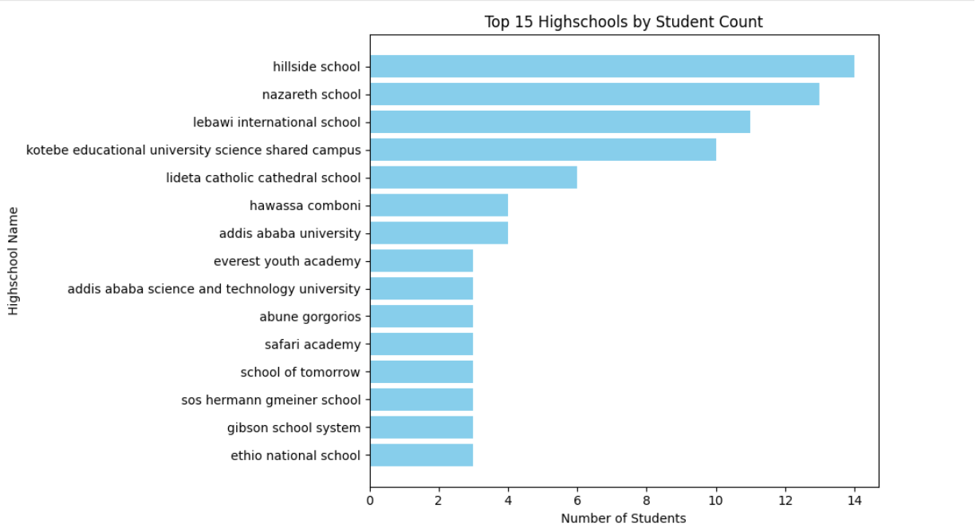

1.2 Citizenship of registered students

- The pie chart shows the citizenship distribution of registered students.
- The data shows that most registered students are from Ethiopia (97.9%), while smaller proportions come from the United States, Eritrea, and South Korea.
- Although this suggests potential growth in those regions, the current available data is limited to make a conclusion that there is a strong potential (for example, internet access in Eritrea is very limited, and some South Korean students may have learned about the program because they live in Ethiopia).
- This information will help the marketing team determine on whom they need to focus on/ target. If the goal is to attract more international students, this chart highlights the need to advertise in different countries or regions.
- Understanding the student base also allows the company to design tailored programs, services, and communications suited to the dominant citizenship group while also accommodating minority groups.

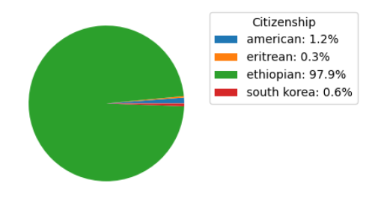

1.3 Time of commitment by department

- The graph shows the time commitment of students in both departments (Engineering basics, Medicine basics).
- Most of the students are willing to commit 8-10 hours per week followed by 11-15.These might help program/ content developers to design contents (notes/videos/activities…) that could fit 8-15 hrs / week time frame to make it effective.

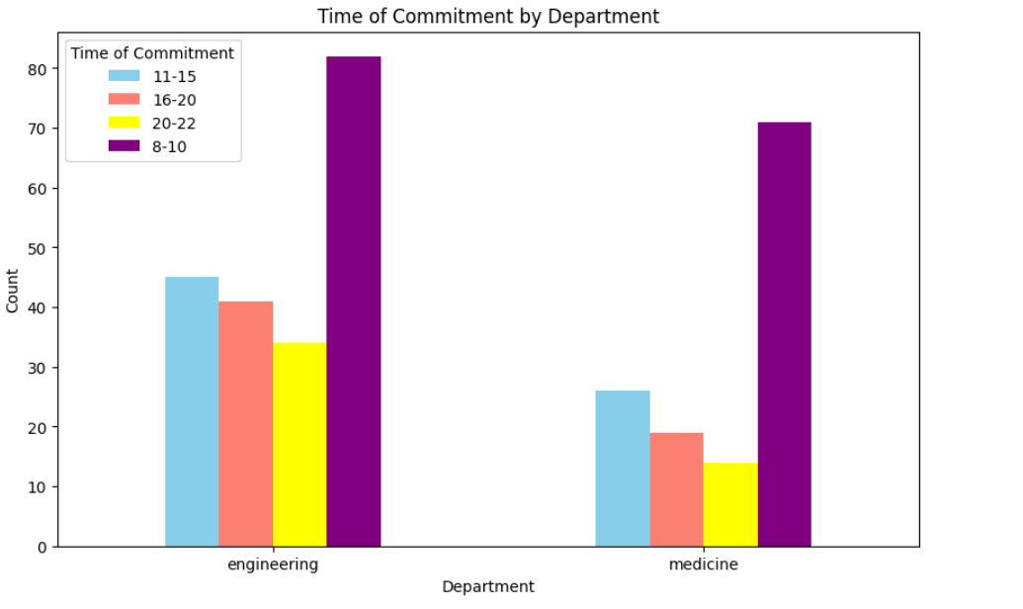
1.4 Grade level of registered students

- The two graphs below show the grade level of students registered in both departments.
- This data helps to understand which grade level students are most interested or aware of the training.

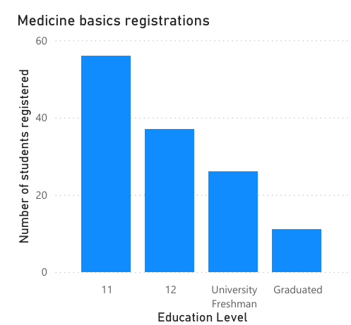
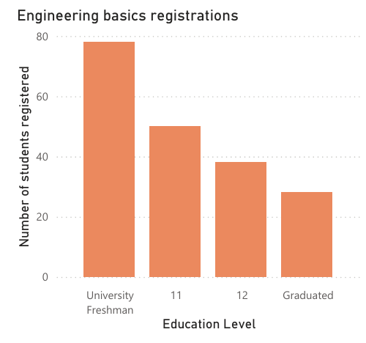

1.5 Mean GPA of the students

- The graph below shows the mean GPA of registered students in both departments.
- This data helps to understand that most students have a GPA above 3.5, which is considered high.
- The data also highlights the strong academic background of students which indicate the need to tailor the program to match their level.

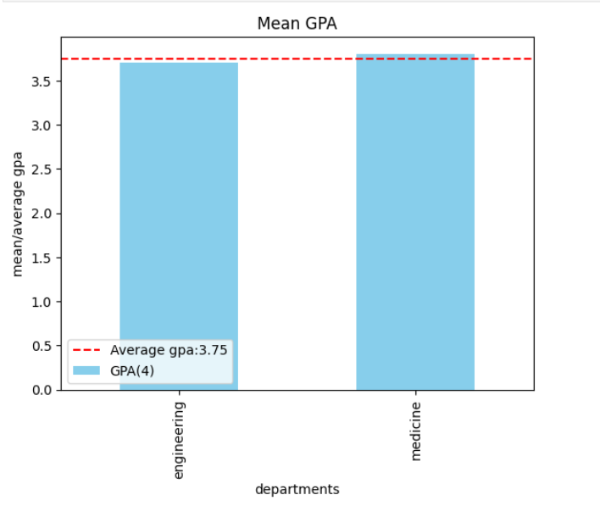

1.6 Linkedin followers in percentage

- The graph shows how much of the students registered follow linkedin.
- Since most of the registered students already follow the company, it shows LinkedIn is an effective channel for communication, updates, and engagement.

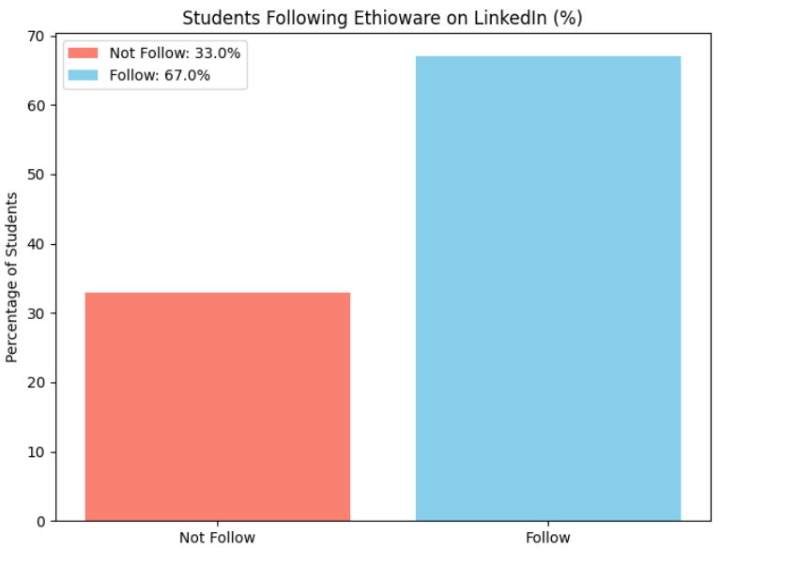

- February and May Cohort Analysis Results

2.1 Student Demographics and Interests
- The merged data from the February and May cohorts shows a strong interest in foundational, multi-disciplinary fields, with medicine basics (7 mentions), engineering basics (4 mentions), and software (2 mentions) being the most popular.
- The data also indicates that a significant portion of the "Presenter Background" information is not specified, suggesting a need for improved data collection.
2.2 Challenges and Resolutions
- The most common challenges students faced were time management and exams, each mentioned twice.
- Other challenges included "complex algorithms" and "grasping advanced concepts."
- Students actively overcame these challenges by using resources like Khan Academy, seeking mentorship, and adjusting their personal schedules.
- Actionable Insight: The curriculum team should incorporate lessons on project planning, time management, and study skills to help students balance the program with their academic lives. This addresses a core pain point for many participants.
2.3 Program Impact and Aspirations
- A qualitative review of the "Future Aspirations" and "Key Takeaway" columns, visualized in a word cloud, shows that the program is highly effective at shaping and reinforcing students' career goals.
- Common aspirations include becoming a professional engineer, a neurologist, or a surgeon. The primary takeaways for students emphasize the importance of continuous learning, teamwork, and the program's. transformative power.
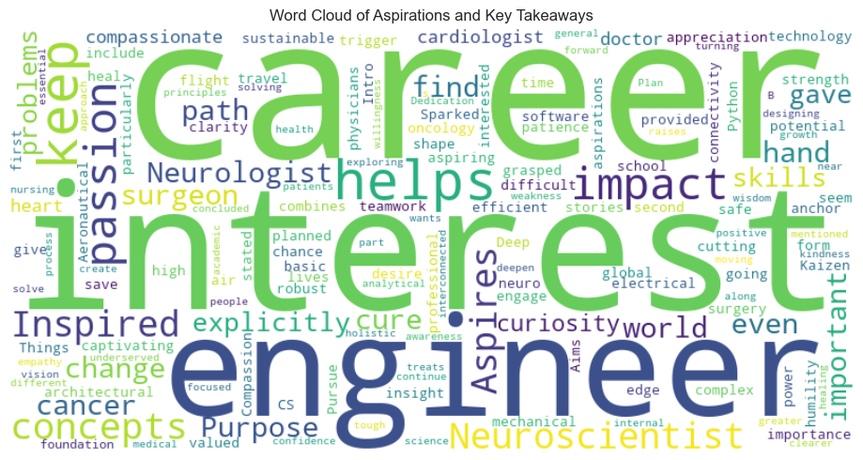
- Actionable Insight: The program's narrative should highlight these transformative journeys. Marketing materials can feature testimonials from students whose career paths were solidified by their participation.
2.4 Marketing Performance
- An analysis of the May cohort revealed that word-of-mouth is the most effective marketing channel, with the most frequent answers being "A close friend's recommendation." This indicates a highly satisfied participant base and points to the potential for a formal referral program.
- Actionable Insight: The marketing department should capitalize on this by creating a formal referral program. Incentivizing students to recommend the program will reinforce its most effective recruitment channel

- May Cohort Score Analysis Results

3.1 Average Quiz score

- The graph is right skewed, most of the scores are in the high end with mode 6.84.

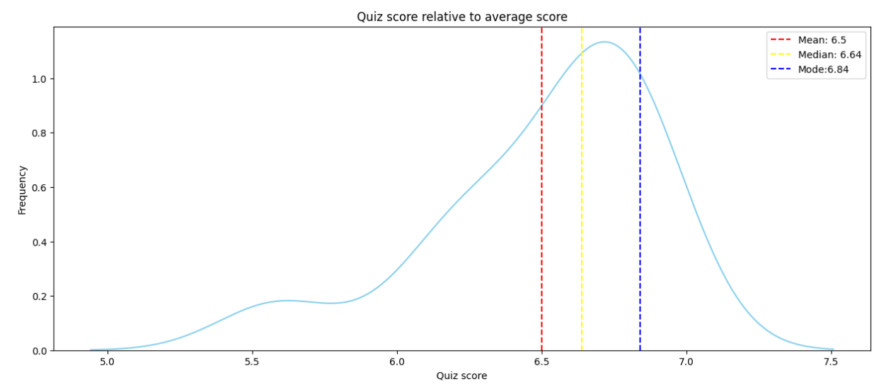

3.2 Average quiz score by cohort

- Medicine Basics students get slightly more than average score in quiz.

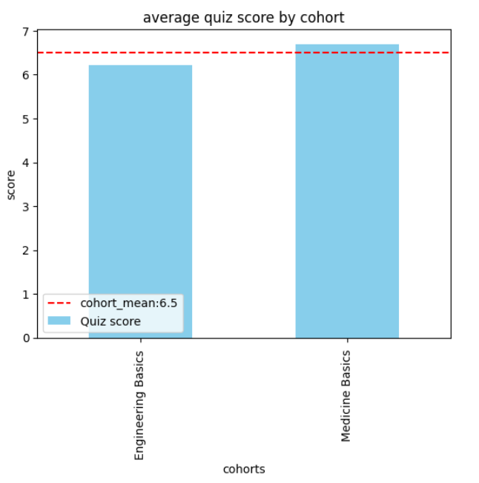

3.3 Commitment Time vs Quiz score mean

- Students( who chose to commit 8-10 hrs) got slightly better quiz scores than others.
- Students(who chose to commit 20-22 hrs) got lower quiz scores than others.

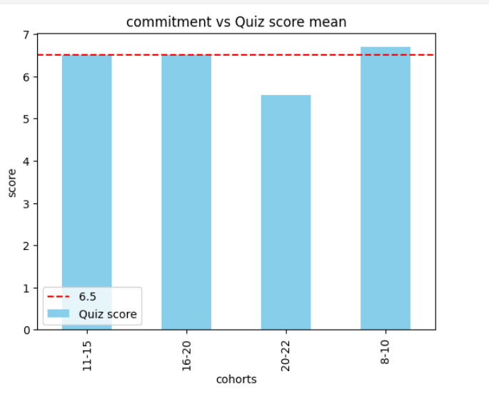

3.4 Relative to top scorer

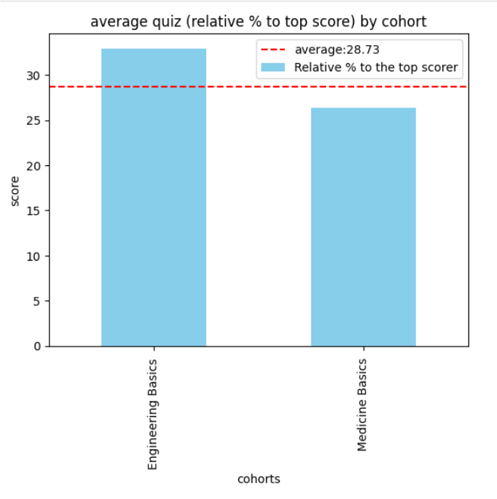

3.5 Distribution of Average

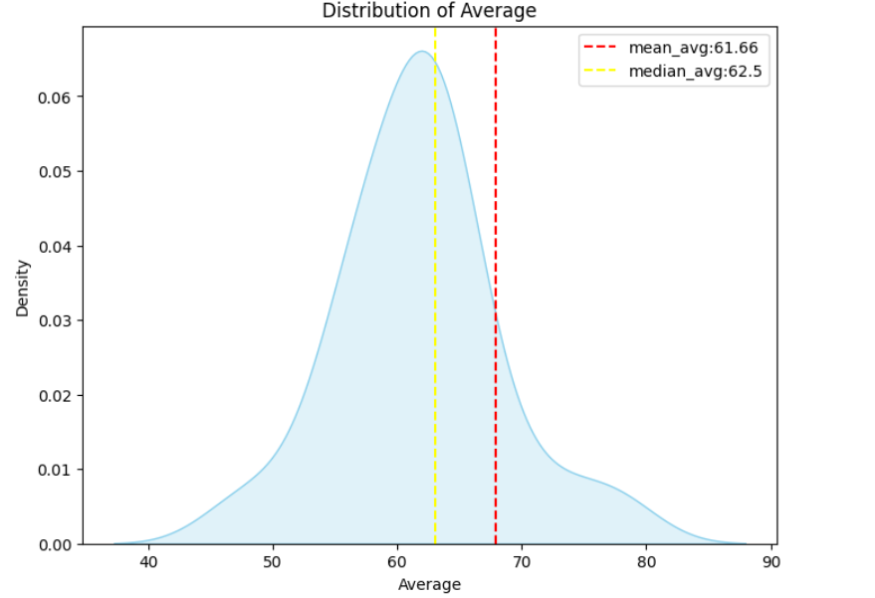

- Engineering Basics Score Analysis Results

4.1 Methodology

- This analysis is based on 7,566 assignment records from a 30-day window, covering 200 unique assignments across 6 content types for a cohort of 26 active students.
- Data was analyzed using Python and Pandas to measure KPIs, learning velocity, engagement, and content effectiveness.
4.2 Overall Performance and Effectiveness
- Overall Performance Metrics:
Metric | Value | Interpretation
Overall Completion Rate | 87.3% | Excellent engagement level
Average Score Rate | 86.7% | Strong content mastery
Best Score Rate | 83.7% | Good improvement potential
Retry Rate | 37.0% | Healthy persistence behavior
On-time Submission | 65.3% | Moderate timeliness
Score Improvement Rate | 56.8% | Good learning progression

- Key Insight: Students demonstrate strong engagement and content mastery with room for improvement in consistent on-time submission.
- Assignment Type Performance:
Content Type | Completion Rate | Effectiveness Score | Student Count
Exercises | 87.3% | 56.4 | 1,248 assignments
Quizzes | 78.9% | 53.0 | 182 assignments
Unit Tests | 54.0% | 40.5 | 78 assignments
Videos | N/A | N/A | 3,666 assignments
Articles | N/A | N/A | 1,716 assignments

- Key Findings: Exercises are the most effective content type, while Unit Tests represent the greatest challenge to students with the lowest completion rate. Quizzes successfully balance difficulty and effectiveness. While videos and articles show strong utilization, they have limited measurable outcomes.
4.3 Detailed Student Performance Analysis
- Top Performing Students:
  - Yusra Sherif - 92.5% completion rate, 56.9 engagement score
  - Amanuel Tsehay - 84.1% completion rate, 62.4 engagement score
  - Mihret Dereje - 84.5% completion rate, 50.7 engagement score
- Learning Velocity Leaders: Wudase Mehari is the fastest learner with an average completion time of 4.2 days, followed by Bonsa Desalegn and Mihret Dereje, both with an average of 4.4 days.
- Risk Profile Analysis: Most students show minimal risk indicators, with Mihret Dereje having the highest risk score at 0.055, which suggests a need for monitoring. A total of 14 students showed perfect engagement patterns with a zero risk score.
- Engagement Scoring Methodology: Engagement was scored using a composite methodology that assigned a 40% weight to completion rate, a 30% weight to timeliness, a 20% weight to improvement, and a 10% weight to efficiency.
- Learning Consistency Analysis: Learning consistency was measured by the coefficient of variation in completion rates. Students with high consistency showed low variation in performance, indicating reliable study habits and content mastery.
- Time-Based Learning Insights: The average time to complete an assignment was 4.7 days. The on-time submission rate was 65.3%, with minimal overdue assignments.

- Detailed Student Performance Report

5.1 Key Performance Indicators (KPIs)
The analysis of student learning activity using Khan Academy reveals a clear divide between highly engaged and disengaged students.
- Overall Mastery Rate: The average mastery rate across all students is 31.01%. This metric, which measures the proportion of skills mastered out of those worked on, suggests that while many students are progressing, there is room for improvement in helping them achieve full mastery.
- Proficiency Progression Rate: The average rate is 0.0314 skills/minute. This indicates how quickly students, on average, are advancing their proficiency levels for the time they invest.
- Mastery Efficiency: Focusing only on students who have logged at least one minute of learning, the mastery efficiency is 56.15%. This is a significant insight, showing that for students who are actively engaged, the platform is quite effective at converting effort into mastery.
- The top-performing students consistently show high mastery rates. Raniya Zakir stands out with a perfect 100% mastery rate, while bsisay6342 (95.35%) and Amira Ali (94.03%) also demonstrate exceptional performance.
- Student Disengagement Rate: This is a major area of concern. 29.63% of students (8 out of 27) have logged zero learning minutes. This suggests a significant portion of the cohort is not using the platform, which could be due to technical issues, lack of motivation, or other barriers.
- Learning Stagnation Rate: 14.81% of students (4 out of 27) are categorized as "stagnant." These students have invested time on the platform but have not leveled up any skills, indicating potential struggles with the material or ineffective learning strategies.
- Proficiency Inefficiency: The notebook's analysis found zero students who met the threshold of a high time investment (>500 minutes) and a low mastery rate (<20%). This is a positive finding, as it suggests that students who are putting in significant effort are generally seeing proportional results.
5.2 Learning Insights and Correlations
- A strong positive correlation (0.68) exists between total learning minutes and the number of skills mastered. This reinforces the value of consistent student engagement.
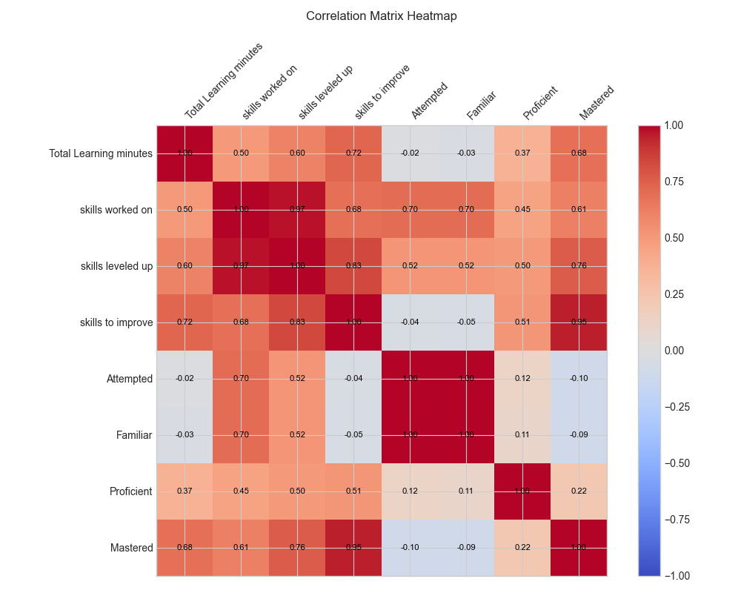
- The analysis shows a clear divide in the student cohort between highly engaged and effective learners, and a large group of disengaged or struggling students. The platform appears effective for those who use it consistently, but there are significant issues with initial engagement and potential stagnation.
- Experience Rating and Sentimental Analysis Results

Mentors:

6.1 Mentors’ general experience ratings

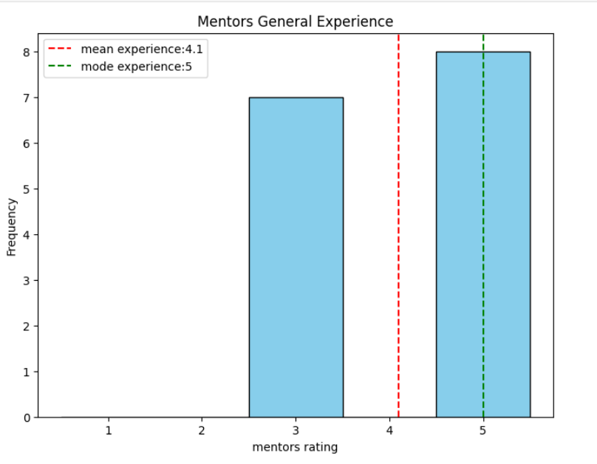
6.2 Mentors’ recommendation ratings

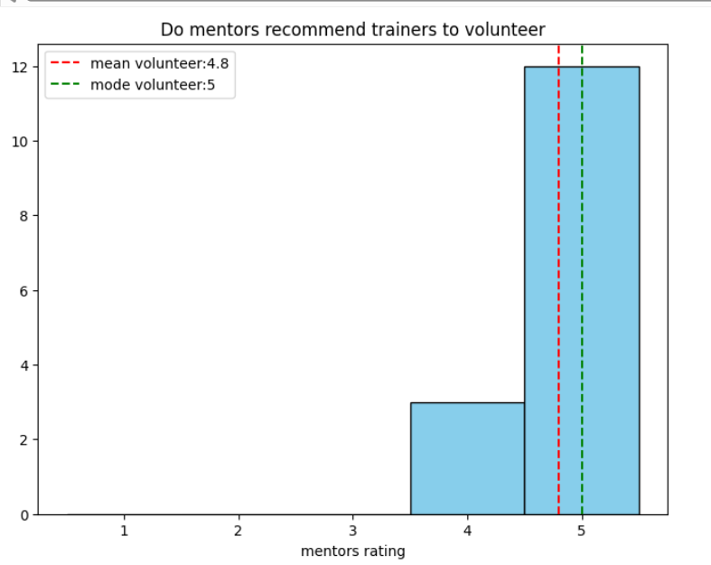
6.3 Sentimental Analysis

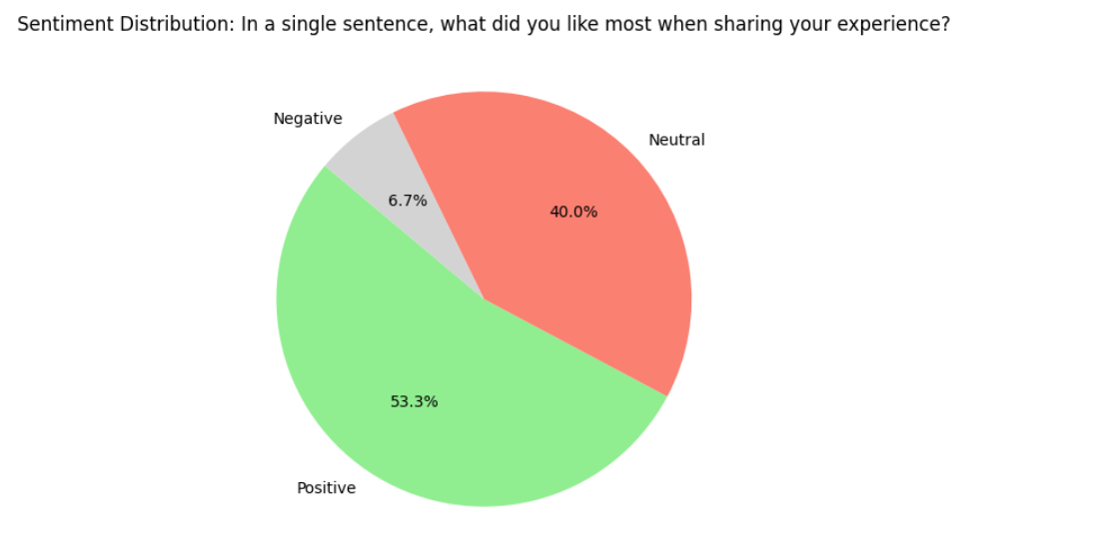
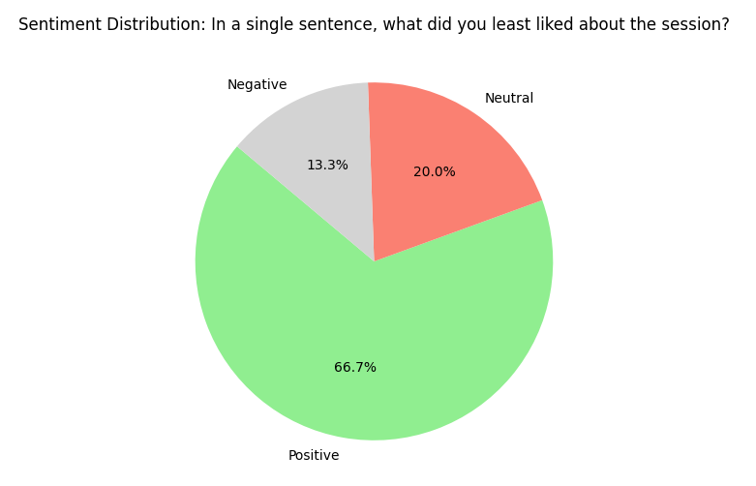
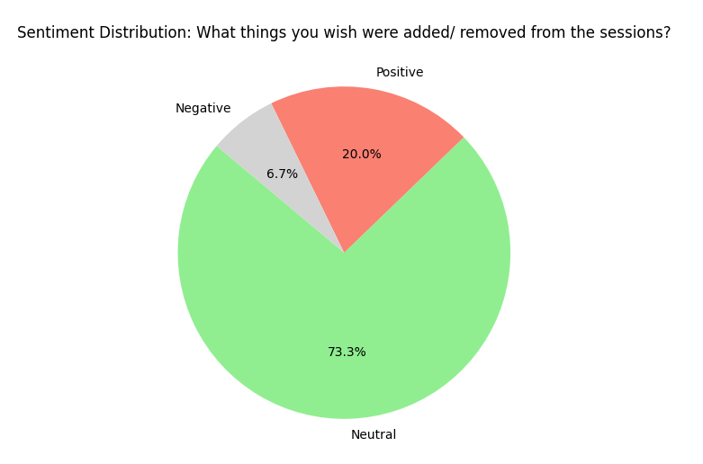

Anonymous Trainee Feedback
6.4 Quantitative Ratings
- This analysis is based on the Anonymous_rating_Engineering_basics_clean_data.csv dataset. And the survey data shows a strong positive response with an average rating of 4.29 out of 5 for both general experience and relevant information. This indicates a high level of satisfaction with the program's content and overall experience.
The quantitative ratings from the survey show a strong positive response.
- Average General Experience Rating: 4.29 out of 5
- Average Relevant Information Rating: 4.29 out of 5
- Average Recommendation Likelihood: 4.14 out of 5
6.5 Qualitative Feedback and Sentiment
- Sentiment analysis of open-ended feedback is overwhelmingly positive, with trainees praising the opportunity to learn new technologies and network with instructors. The most prominent complaint is the fast-paced nature and short duration of each topic.
- The sentiment analysis of the "what they liked most" and "what they liked least" sections provides granular insight.
- What was liked most: The sentiment is overwhelmingly positive. Themes from the raw data include "learning about new technologies," "meeting different instructors," and the "communication and networking aspect."
- What was liked least: While some responses are negative, the sentiment is generally mixed or neutral. The most prominent complaint is the short duration of each topic and the fast-paced nature of the program.
- Actionable Insight: The program is excelling at providing networking and exposure to professionals. These elements should remain central to the curriculum. To address the negative feedback, consider making the content more modular, allowing trainees to delve deeper into specific topics at their own pace.
Keyword Frequency Analysis and Word Cloud
- The keyword frequency analysis from the combined feedback text shows which topics are top of mind for trainees. The most frequent keywords include:
- time (related to time management)
- technologies
- learning
- friendly
- content
- The word cloud visually reinforces this, with "friendly," "learning," and "time" being some of the largest words.
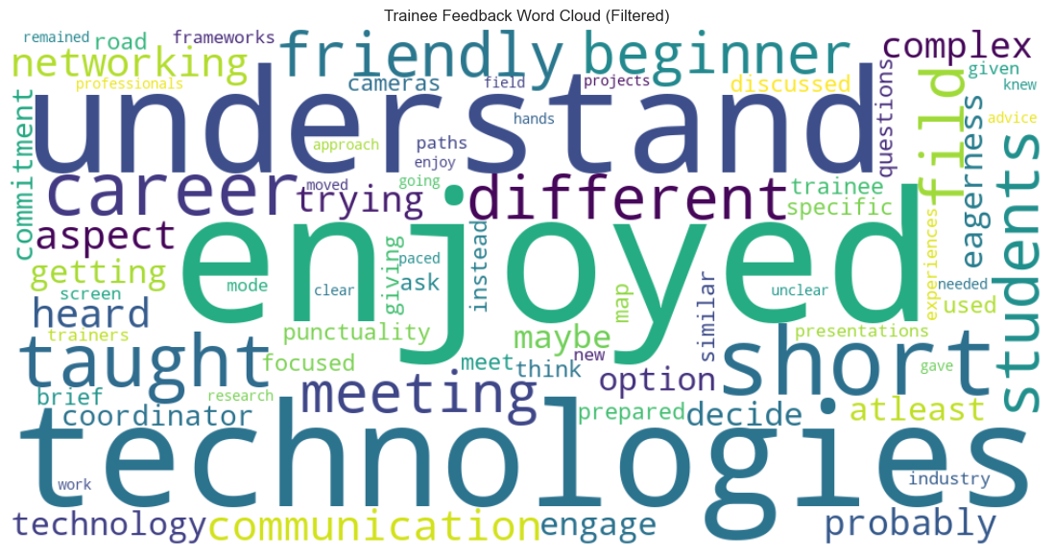
- Actionable Insight: This provides a direct feedback loop for the curriculum team. The praise for "beginner friendly content" confirms that the introductory approach is working. The continued mention of "time" reiterates the need for more flexible scheduling or time management support.
6.6 Key themes and recommendations
- Keyword analysis from the feedback highlights friendly, learning, and time as key themes. This confirms that the beginner-friendly approach is working. To address negative feedback, it is recommended to consider making content more modular, allowing trainees to delve deeper into specific topics at their own pace.

